**ATM CPE Management**Objective:   
  
All CPE can be reachable to get useful information which is necessary for the problems troubleshooting.  
  
  
  
CPE Management is divided into three main parts:   
  
- Management configuration on Modem.  
  
- CPE Management configuration on DSLAM.  
  
- CPE Management configuration on provider Edge router (PE).  
  
  
  
Part 1: Management configuration on Modem  
  
kindly check all modems configuration on wiki.

Part 2: CPE Management configuration on DSLAMs

A- ATM DSLAM   
  
B- Zyxel DSLAM [IES-6000]  
  
C- Zyxel DSLAM [IES-708]

Part3: CPE Management configuration on provider Edge router (PE).

A- ATM DSLAM   
  
B- Zyxel DSLAM

Part 2: CPE Management configuration on DSLAMs

A- ATM DSLAM

1-select configuration then ATM Management

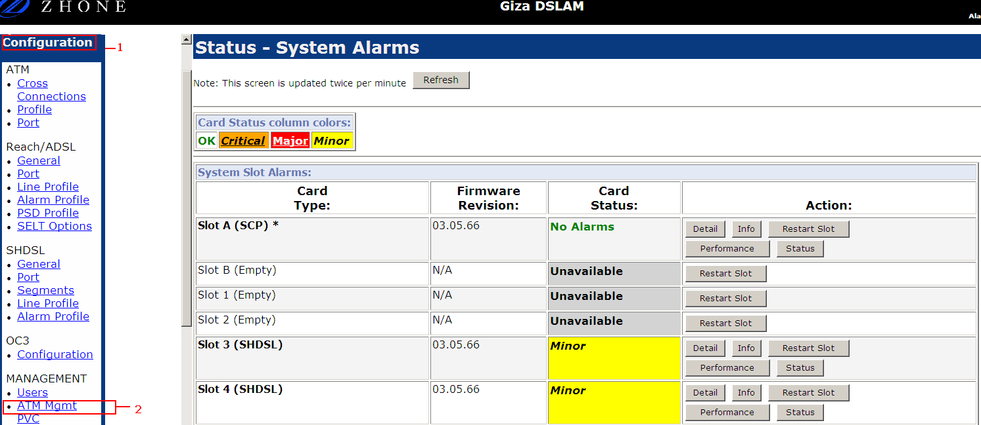

2-select create New Entry

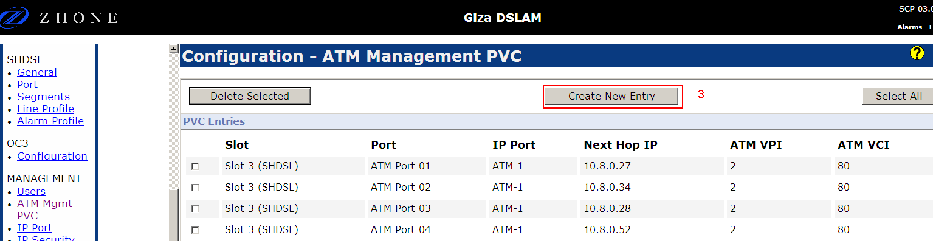

3-set Management IP Address and VPI/VCI

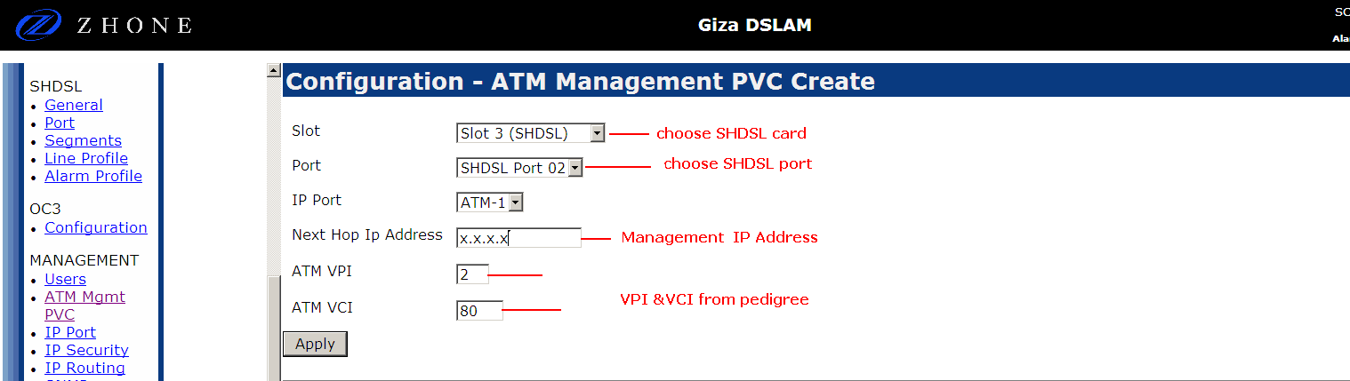

4-The result will be like the following  
  
  
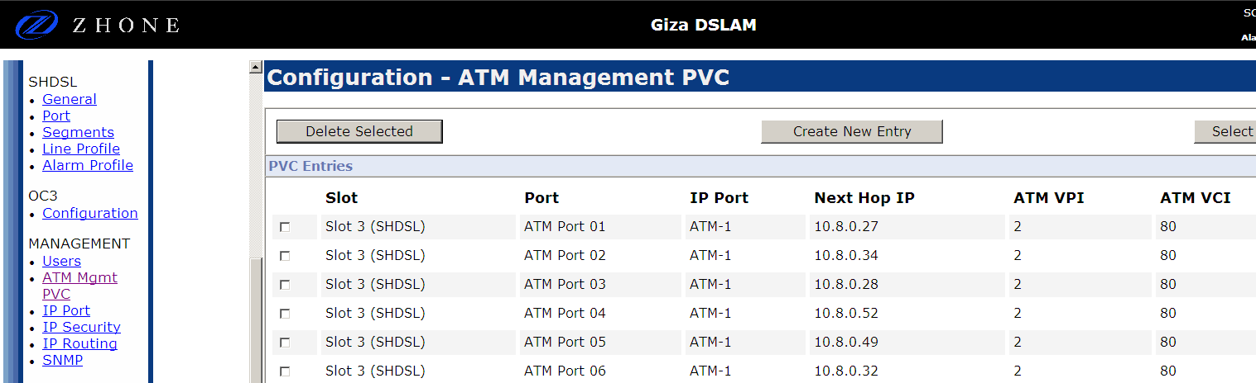

B- Zyxel DSLAM [IES_6000]  
  
1-select port then IP Bridge

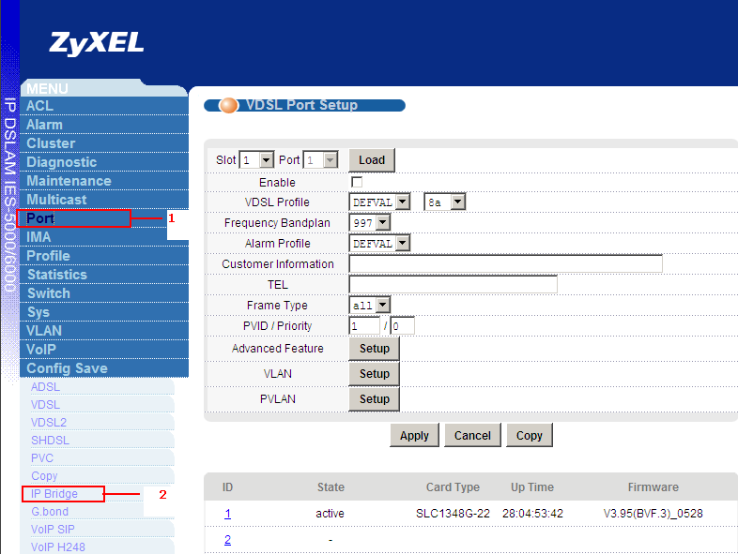

2- Create IPBPVC  
  
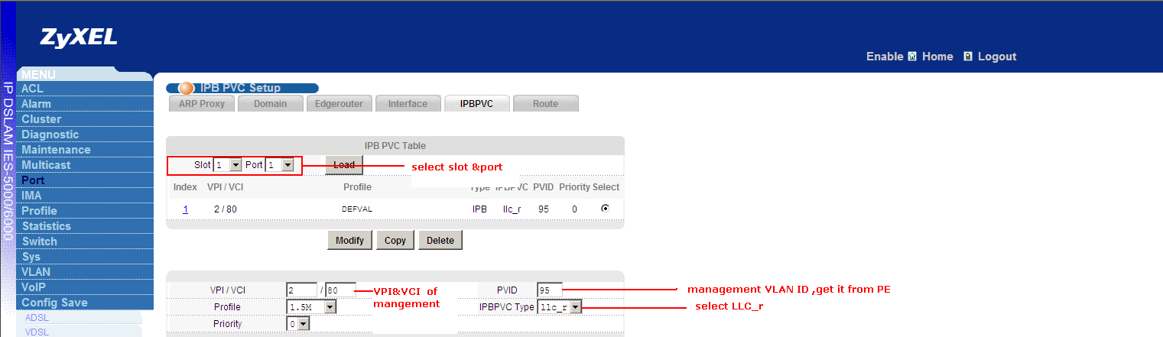

3-create interface  
  
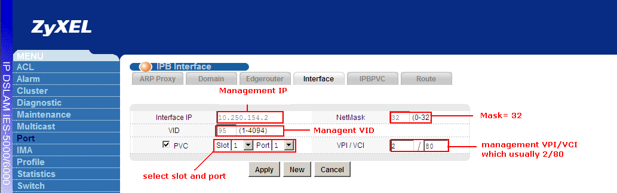

4-the result will be like the following  
  
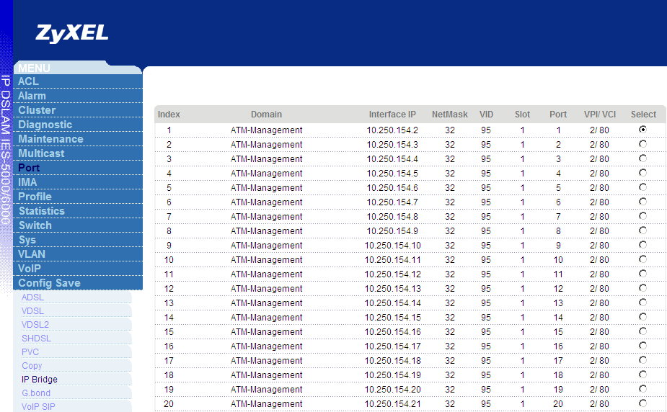

C- Zyxel DSLAM [IES_-708]  
  
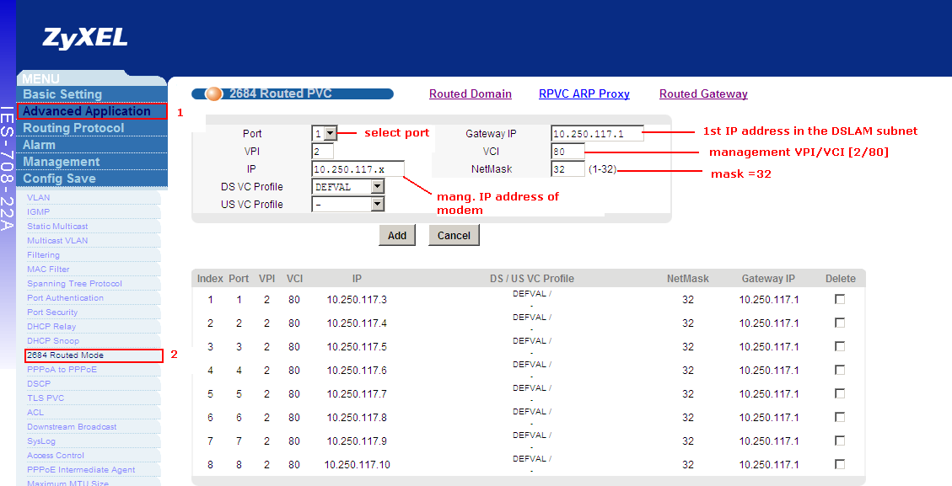

- The result will be like the following:  
  
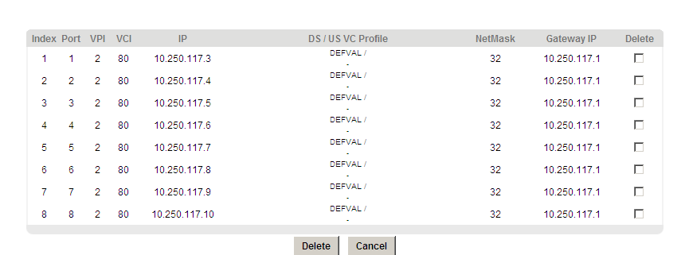

- CPE Management configuration on provider Edge router (PE):   
  
  
A- ATM DSLAM:  
  
-DSLAM IP Address and CPE management IPs are in the same subnet so we will never face any routing issue  
  
- So if the DSLAM is reachable. The CPE will be also reachable.

Example: Giza ATM DSLAM  
  
DSLAM IP Address: 10.8.0.2  
  
CPE management Subnet: 10.0.8.0/24  
  
in order to make sure that DSLAM is reachable from all PEs, this subnet has to be advertised via ISIS  
  
Snapshot:  
  
  
  
pe1.giza.ca.vxr#sh int des | i DSLAM

AT1/0.99 up up Giza DSLAM Management @512K  
  
  
pe1.giza.ca.vxr#sh run int AT1/0.99

interface ATM1/0.99 point-to-point

description Giza DSLAM Management @512K

ip address 10.8.0.1 255.255.255.0

no atm enable-ilmi-trap

pvc 14/99

abr 666 666

oam-pvc 0

encapsulation aal5snap  
  
  
  
pe1.giza.ca.vxr#sh run | s isis

passive-interface GigabitEthernet0/2

passive-interface GigabitEthernet0/2.80

passive-interface GigabitEthernet0/2.81

passive-interface GigabitEthernet0/2.82

passive-interface GigabitEthernet0/2.100

passive-interface ATM1/0.99

passive-interface Loopback0

mpls traffic-eng router-id Loopback0

mpls traffic-eng level-2

B- Zyxel DSLAM  
  
-For Zyxel DSLAM, the situation is different from ATM DSLAM as Zyxel DSLAM management and CPE management are in two different subnets.  
  
-So we have two make sure that both subnets are advertised via ISIS.   
  
Example: Rehab Zyxel DSLAM   
  
 DSLAM IP Address: 10.240.240.114  
  
 ATM CPE management Subnet: 10.250.154.0/26  
  
 pe.alma.ca.asr1#sh int des | i Rehab

Gi0/0/1.84 up up Rehab Ethernet DSLAM Management

Gi0/0/1.95 up up Rehab ATM-CPE managemen  
  
  
pe.alma.ca.asr1#sh run int Gi0/0/1.84

interface GigabitEthernet0/0/1.84

description Rehab Ethernet DSLAM Management

encapsulation dot1Q 84

ip address 10.240.240.113 255.255.255.252  
  
  
pe.alma.ca.asr1#sh run int Gi0/0/1.95

interface GigabitEthernet0/0/1.95

description Rehab ATM-CPE management

encapsulation dot1Q 95

ip address 10.250.154.1 255.255.255.192  
  
 pe.alma.ca.asr1#sh run | s isis

passive-interface GigabitEthernet0/0/1

passive-interface GigabitEthernet0/0/1.7

passive-interface GigabitEthernet0/0/1.8

passive-interface GigabitEthernet0/0/1.9

passive-interface GigabitEthernet0/0/1.10

passive-interface GigabitEthernet0/0/1.79

passive-interface GigabitEthernet0/0/1.80

passive-interface GigabitEthernet0/0/1.81

passive-interface GigabitEthernet0/0/1.82

passive-interface GigabitEthernet0/0/1.83

passive-interface GigabitEthernet0/0/1.84

passive-interface GigabitEthernet0/0/1.85

passive-interface GigabitEthernet0/0/1.86

passive-interface GigabitEthernet0/0/1.87

passive-interface GigabitEthernet0/0/1.88

passive-interface GigabitEthernet0/0/1.89

passive-interface GigabitEthernet0/0/1.90

passive-interface GigabitEthernet0/0/1.91

passive-interface GigabitEthernet0/0/1.92

passive-interface GigabitEthernet0/0/1.93

passive-interface GigabitEthernet0/0/1.94

passive-interface GigabitEthernet0/0/1.95

passive-interface GigabitEthernet0/0/1.96

passive-interface GigabitEthernet0/0/1.97

passive-interface GigabitEthernet0/0/1.98

passive-interface GigabitEthernet0/0/1.99